MULLION PARISH COUNCIL AGENDA

I hereby summon you to attend the Mullion Parish Council Meeting to be held at 7.00pm on Tuesday 18 July 2023 in the Mullion Methodist Chapel Centenary Room, Churchtown, Mullion. The public and press are cordially invited to attend. Any plans are available to view from 6.30pm.

- Public Session
- To ratify the appointment of the Vice Chairman
- Apologies for Absence
- To agree the Minutes of the Parish Council Meeting held on Tuesday 20 June 2023
- Declarations of Interest – Members to declare pecuniary and non pecuniary interests (including details thereof) in respect of any item(s) on this Agenda
- Planning - See Attached list
7. Report from Cornwall Councillor Anthony Soady
8. Chairman and Clerks Comments
9. Public Rights of Way
10. Public Open Spaces
11. Highways
12. To discuss the installation of height barriers at the entrance of Tremenhee Car Park
13. To receive any LGA 1972 Section 137 Requests for funding
14. To complete the Conflict of Interest form for
15. To agree payment of invoices - Finance and Accounts
16. Other correspondence received
17. To co-opt two Parish Councillors

Exclusion of the Press and Public
Pursuant to the provision of the Public Bodies (Admissions to meetings) Act 1960, the press and public be excluded from the Meeting for the following items of business by reason of the confidential nature of the business to be transacted.

18. Planning Enforcement Matters

Meeting to withdraw if necessary under the Public Bodies Admissions to Meetings Act 1960 Section 1, Local Government Act 1972 Section 100 Sections 2 & 3 and Local Government Act 172 Schedule 12 Section 42. Given under my hand this Eleventh Day of July 2023.

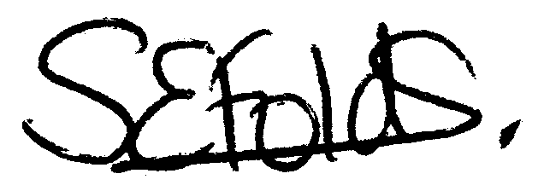

Samantha Folds
Clerk to Mullion Parish Council
Planning

Applications for discussion

PA23/04388 – Polurrian Hotel – Proposed improvement works to public right of way numbers 221/58/3; 221/36/2 and 221/36/1

PA23/04984 – National Trust - Poldhu Beach – New timber boardwalk footpath

Decisions made by Cornwall Council

PA22/09507 - Mullion Gallery, Nansmellyon Road - Proposed Demolition of former gallery to form 3 dwellings without compliance with condition 2 of decision notice PA19/09673 dated 15/06/2021 (Appeal Ref APP/D0840/W/21/3278655 dated 09/02/2022) - Approved

PA23/03879 - This Ll Do, The Commons - Proposed loft conversion, extensions and internal alterations - Approved

Appeals

