MULLION PARISH COUNCIL AGENDA

I hereby summon you to attend the Mullion Parish Council Meeting to be held
on Tuesday 15 March 2022 at 7.00pm in the Mullion Methodist Chapel Centenary Room. The public and press are cordially invited to attend.

- Public Session

2. Apologies for Absence

3. To agree the Minutes of the Parish Council Meeting held on Tuesday 15 February 2022

4. Declarations of Interest – Members to declare pecuniary and non pecuniary interests (including details thereof) in respect of any item(s) on this Agenda

5 Planning

See Attached list

6. Report from Cornwall Councillor Mr Anthony Soady

7. Chairman and Clerks Comments

8. Public Rights of Way (inc. the Tender for the Public Rights of Way Contract)

9. Public Open Spaces

10. Highways

11. To receive any LGA 1972 Section 137 Requests for funding

12. To agree payment of invoices - Finance and Accounts

13. Other correspondence received

The Council is invited to pass the following resolution “that pursuant to the Public Bodies (Admissions to Meetings) Act 1960, the press and public be excluded from the meeting for the following items of business by reason of the confidential nature of the business to be transacted”.

14. Planning Enforcement Cases

Given under my hand this Eighth day of March 2022.
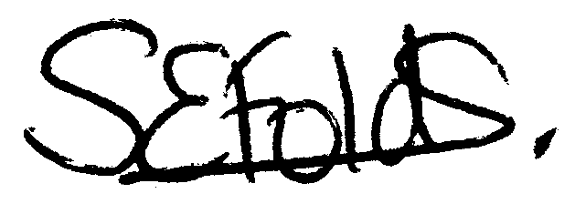

Samantha Folds
Clerk to Mullion Parish Council
Planning

Applications for discussion

PA22/00978 - St Francis, Eglos Parc - To extend and convert the existing garage into a habitable space with internal remodelling. New roof to be pitched and inline with existing

PA22/01550 - 47 Redannack North - Proposed side extension including alterations to existing dwelling

PA22/01682 - Land North Of Little Polbream Farm, Trevitho Lane - Erection of a general purpose agricultural building for fodder and machinery storage

PA21/12744 - Clifden Park Mullion, Football Club, Clifden Close - Installation of a new floodlighting system

Decisions made by Cornwall Council

PA21/08894 Mr & Mrs M. And S. Williams - Vos Brea, 88 Laflouder Fields - Proposed alterations and first floor extension - Approved

Appeals

PA21/01125 - Clifden, Polurrian Cliffs, Mullion – Mr S Sharland and Miss D Gilmore - Appeal Allowed. No Costs claimed

PA19/09673 – Mullion Gallery, Nansmellyon Road, Mullion – Mr Thornton – Appeal Allowed. No Costs claimed

