MULLION PARISH COUNCIL AGENDA

I hereby summon you to attend the Mullion Parish Council Meeting to be held at 7.00pm on Tuesday 15 April 2025 in the Mullion Methodist Chapel Centenary Room, Churchtown, Mullion. The public and press are cordially invited to attend.

- Public Session
- Apologies for Absence
- To agree the Minutes of the Parish Council Meeting held on Tuesday 18 March 2025
- To receive any Declarations of Interest in relation to this Agenda
- Planning - See Attached list
6. Chairman and Clerks Comments
7. Public Rights of Way
8. Public Open Spaces
9. Highways
10. To receive any LGA 1972 Section 137 Requests for funding
11. To agree payment of invoices - Finance and Accounts
12. Other correspondence received

Exclusion of the Press and Public
Pursuant to the provision of the Public Bodies (Admissions to meetings) Act 1960, the press and public be excluded from the Meeting for the following items of business by reason of the confidential nature of the business to be transacted.

13. Planning Enforcement Matters

Meeting to withdraw if necessary under the Public Bodies Admissions to Meetings Act 1960 Section 1, Local Government Act 1972 Section 100 Sections 2 & 3 and Local Government Act 172 Schedule 12 Section 42. Given under my hand this Eighth Day of April 2025.

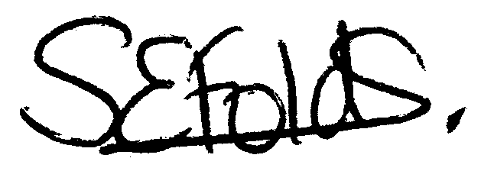

Samantha Folds
Clerk to Mullion Parish Council
Planning

Applications for discussion

PA25/02048 - White Wings Polhorman Lane - Erection of rear single-storey conservatory

PA25/02054 - Mundys Cellar, Mullion Cove - Listed Building Consent for re-roofing of existing building on like for like basis

Decisions made by Cornwall Council

Appeals

