MULLION PARISH COUNCIL AGENDA

I hereby summon you to attend the Mullion Parish Council Meeting to be held at 7.00pm on Tuesday 16 January 2024 in the Mullion Methodist Chapel Centenary Room, Churchtown, Mullion. The public and press are cordially invited to attend. Any plans are available to view from 6.30pm.

- Public Session including the presentation of the Outstanding Contribution to Mullion Award
- Apologies for Absence
- To agree the Minutes of the Parish Council Meeting held on Tuesday 19 December 2023
- Declarations of Interest – Members to declare pecuniary and non pecuniary interests (including details thereof) in respect of any item(s) on this Agenda
- Planning - See Attached list
6. Report from Cornwall Councillor Anthony Soady
7. Chairman and Clerks Comments
8. Public Rights of Way
9. Public Open Spaces
10. Highways
11. To receive any LGA 1972 Section 137 Requests for funding
12. To agree payment of invoices - Finance and Accounts
13. Other correspondence received

Exclusion of the Press and Public
Pursuant to the provision of the Public Bodies (Admissions to meetings) Act 1960, the press and public be excluded from the Meeting for the following items of business by reason of the confidential nature of the business to be transacted.

14. Planning Enforcement Matters

Meeting to withdraw if necessary under the Public Bodies Admissions to Meetings Act 1960 Section 1, Local Government Act 1972 Section 100 Sections 2 & 3 and Local Government Act 172 Schedule 12 Section 42. Given under my hand this Ninth Day of January 2024.

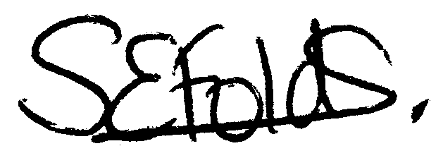

Samantha Folds
Clerk to Mullion Parish Council
Planning

Applications for discussion

PA23/09508 – Treverbyn, Polurrian Cliffs - Proposed front and rear single-storey extensions, internal alterations and creation of a new rear access

PA24/00024 – Wayfield, Polhorman Lane - Proposed extension, alterations, external cladding and additional parking Location

PA23/09917 - Land East of Vounder Farmhouse Meaver Road - Proposed development of 6 dwellings (including 4 affordable dwellings), vehicular access, landscaping and associated external works

PA23/10158 - Gwenton Farm, Bochym Hill, Cury Cross Lanes - Removal of Section 106 Agreement in relation to W2/PA99/00978/F dated 27th March 2003 Conversion and extension of redundant barn to dwelling for an agricultural worker and installation of a septic tank

PA23/10346 - Salisbury House, Churchtown - Proposed alterations to existing single-storey rear extension

Decisions made by Cornwall Council

PA23/07116 - Chy An Gweal, 3 Meres Valley - Extensions to dwelling and conversion and extension of garage to form private annexe/studio – Approved

PA23/08530 - Newton Farm, Polhorman Lane - Construction of portal frame building to cover existing Sand School - Approved

Appeals

