MULLION PARISH COUNCIL AGENDA

I hereby summon you to attend the Mullion Parish Council Meeting to be held
on Tuesday 19 February 2019 at 7.00pm
in the Mullion Methodist Chapel Centenary Room, Churchtown, Mullion.
Any plans are available to view from 6.30pm.

- Public Session
- Apologies for Absence
3. To agree the Minutes of the Parish Council Meeting held on Tuesday 15 January 2019
4. Declarations of Interest – Members to declare pecuniary and non pecuniary interests (including details thereof) in respect of any item(s) on this Agenda
5. Planning Applications

Any Planning Applications received from the Planning Authority between the day of the publication of this Agenda and the day of the meeting.

Planning Decisions

PA18/10929 - Mr R Retallack - 6-13 Redannack Estate - Removal of chimneys, change from ground floor windows to patio doors on south west elevation, white Upvc doors to storage unit on NW elevation and addition of cladding – Approved
PA18/11981 - Mr & Mrs D Leonard - Croft Nowyth, The Commons - Demolition of Existing Conservatory and Replacement Sunroom – Approved
PA19/00219 - Mr Daniel Thompson - Trenowyth House, Mullion Cove - Non Material Amendment to Planning Application No. PA18/06276 for extensions and refurbishment of the existing property namely to change patio area to decking construction (size to remain the same) - Approved

And any further Planning Decisions received from the Planning Authority between the day of the publication of this Agenda and the day of the meeting.
6. Report from Cornwall Councillor Mrs C Rule
7. Chairman and Clerks Comments
8. Public Rights of Way
9. Public Open Spaces (inc. spending of amenity money)
10. Highways
11. To discuss the purchase of land to extend the Cemetery
12. To agree the Local Maintenance Partnership 2019-20 for the cutting of the Public Rights of Way
13. To receive any LGA 1972 Section 137 Requests for funding
14. To agree payment of invoices - Finance and Accounts
15. Other correspondence received

The Council is invited to pass the following resolution “that pursuant to the Public Bodies (Admissions to Meetings) Act 1960, the press and public be excluded from the meeting for the following items of business by reason of the confidential nature of the business to be transacted”.

16. Planning Enforcement Cases

Given under my hand this Eleventh day of February 2019.
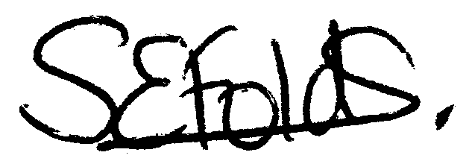

Samantha Folds
Clerk to Mullion Parish Council

