MULLION PARISH COUNCIL AGENDA

I hereby summon you to attend the Mullion Parish Council Meeting to be held
on Tuesday 18 January 2022 at 7.00pm in the Mullion Methodist Chapel Centenary Room. The public and press are cordially invited to attend.

- Public Session

2. Apologies for Absence

3. To agree the Minutes of the Parish Council Meeting held on Tuesday 16 November 2021

4. Declarations of Interest – Members to declare pecuniary and non pecuniary interests (including details thereof) in respect of any item(s) on this Agenda

5 Planning

See Attached list

6. Report from Cornwall Councillor Mr Anthony Soady

7. Chairman and Clerks Comments

8. Public Rights of Way

9. Public Open Spaces

10. Highways – including the “20’s Plenty Campaign”

11. To discuss the Award for Outstanding Contribution to Mullion

12. To agree the Calendar of Meetings for 2022

13. To receive any LGA 1972 Section 137 Requests for funding

14. To agree payment of invoices - Finance and Accounts

15. Other correspondence received

The Council is invited to pass the following resolution “that pursuant to the Public Bodies (Admissions to Meetings) Act 1960, the press and public be excluded from the meeting for the following items of business by reason of the confidential nature of the business to be transacted”.

16. Planning Enforcement Cases

Given under my hand this Eleventh day of January 2022.
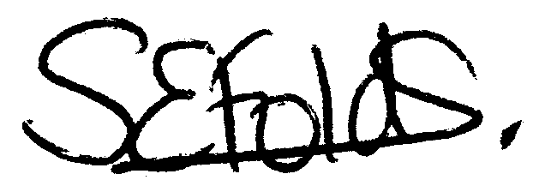

Samantha Folds - Clerk to Mullion Parish Council
Planning

Applications for discussion

PA21/11399 - Land Adj To Laflouder Farm House, Laflouder Lane - Reserved Matters application for access, appearance, landscaping, layout and scale, details following outline consent PA18/09039 dated 04.12.2018

PA21/11771 – Chy Avalenn, Nansmellyon Road – Proposed extensions, alterations and balcony

PA21/09819 – Tremellyon, Polurrian Road – Conversion of existing loft and associated works including new balcony – Amended plans

PA21/12356 – Henscath House, Mullion Cove – Proposed single storey extension

Decisions made by Cornwall Council

PA21/02100 - Mr Long – Trevean, Mullion Cove - Alterations and extensions including raised terrace, with swimming pool and roof conversion with terrace - Approved

PA21/08671 - Braide - Clahar Cottage, Trewoon Road - Listed Building Consent: Internal alterations to ground and first floor elements, removal of existing section of external block work wall from north west elevation to be replaced with cob blocks, lime render and the fitment of a new window within former window opening

Appeals

PA21/01794 - Gwel Teg 47 Laflouder Fields - Change of use from office to ancillary accommodation and occasional holiday let - Appeal Allowed, no costs awarded

