MULLION PARISH COUNCIL AGENDA

I hereby summon you to attend the Mullion Parish Council Meeting to be held
on Tuesday 16 March 2021 at 7.00pm remotely – online or by telephone via Microsoft Teams. The public and press are cordially invited to attend. Joining instructions are available by emailing the Clerk on mullionpc@btinternet.com or by calling 01326 241445.

- Public Session
- Apologies for Absence
3. To agree the Minutes of the Parish Council Meeting held on Tuesday 16 February 2021
4. Declarations of Interest – Members to declare pecuniary and non pecuniary interests (including details thereof) in respect of any item(s) on this Agenda
5. Update from the National Trust – Cat Lee and Matt Lewis
6. Planning
Applications
PA21/00389 - Mr Rob Naylor - Valley View, Glenmoor Lane - Small front and rear extensions, slight size increase in existing dormer with associated rear Juliet balcony
PA21/00893 – Mr& Mrs T Powell - Mullion Mini Market Nansmellyon Road - Change of use, conversion and extension to create 4 No. residential units
PA21/01125 - Mr S Sharland & Miss D Gilmore - Proposed Demolition of Existing Dwelling and Erection of 2 Dwellings – Clifden, Polurrian Cliffs
PA21/01739 – Mr & Mrs Hearn – Trenwith, 23 Meres Valley – Formation of porch, extension of dormer, replace conservatory with rear extension
PA21/01754 – Mr & Mrs P Ward – 31 Trembel Road – Proposed extension and internal alterations
Decisions
PA20/09617 - Mrs Henrietta Peterken - Meaver Crease Farm, Meaver Lane - Erection of an extension – Approved
PA21/00057 -Mrs M Crarer - Cove View, Laflouder Lane - Proposed Extension and Alterations – Approved

7. Report from Cornwall Councillor Mrs C Rule
8. Chairman and Clerks Comments
9. Public Rights of Way
10. Public Open Spaces
11. Elections – 06 May 2021
12. Highways
13. To receive any LGA 1972 Section 137 Requests for funding
14. To agree payment of invoices - Finance and Accounts
15. Other correspondence received

The Council is invited to pass the following resolution “that pursuant to the Public Bodies (Admissions to Meetings) Act 1960, the press and public be excluded from the meeting for the following items of business by reason of the confidential nature of the business to be transacted”.

16. Planning Enforcement Cases

Given under my hand this Ninth day of March 2021.
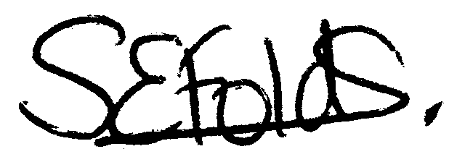

Samantha Folds
Clerk to Mullion Parish Council

