MULLION PARISH COUNCIL AGENDA

I hereby summon you to attend the Mullion Parish Council Meeting to be held
on Tuesday 21 January 2020 at 7.00pm
in the Mullion Methodist Chapel Centenary Room, Churchtown, Mullion.
Any plans are available to view from 6.30pm.
- Public Session
- Apologies for Absence
3. To agree the Minutes of the Parish Council Meeting held on Tuesday 17 December 2019
4. Declarations of Interest – Members to declare pecuniary and non pecuniary interests (including details thereof) in respect of any item(s) on this Agenda
5. Planning Applications
PA19/11177 - Mr Vince Hyde - Campden House, The Commons - Application for reserved matters following outline approval PA18/05838 - approval sought for appearance, landscaping, layout and scale on the most southernmost plot. Applicants also wish to have consent for the temporary sitting of a mobile home on site during construction works
Any further Planning Applications received from the Planning Authority between the day of the publication of this Agenda and the day of the meeting.
Planning Decisions
PA19/10221- Mr M Tattersall & Mrs J Grimmer - Chy Hallow, Nansmellyon Road - Proposed Extension and Internal Alterations – Approved
PA19/05707 - Land off Polurrian Road, Mullion - Outline application with some matters reserved for residential development of up to 25 residential units including vehicular access, internal roads, landscaping, open space, drainage, infrastructure and all associated development. Approval sought for matter of access - Refused
Any further Planning Decisions received from the Planning Authority between the day of the publication of this Agenda and the day of the meeting.
6. Report from Cornwall Councillor Mrs C Rule
7. Chairman and Clerks Comments
8. Public Rights of Way
9. Public Open Spaces
10. Highways
11. To discuss the proposed Waste and Recycling Contract for Cornwall
12. To discuss the purchase of land to extend the Cemetery
13. To receive any LGA 1972 Section 137 Requests for funding
14. To agree payment of invoices - Finance and Accounts
15. Other correspondence received

The Council is invited to pass the following resolution “that pursuant to the Public Bodies (Admissions to Meetings) Act 1960, the press and public be excluded from the meeting for the following items of business by reason of the confidential nature of the business to be transacted”.

16. Planning Enforcement Cases

Given under my hand this Fourteenth day of January 2020.
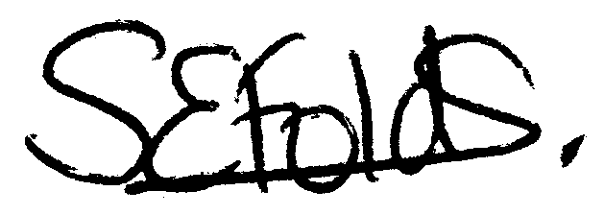

Samantha Folds
Clerk to Mullion Parish Council

