MULLION PARISH COUNCIL AGENDA

I hereby summon you to attend the Mullion Parish Council Meeting to be held
on Tuesday 19 January 2021 at 7.00pm remotely – online or by telephone via Microsoft Teams. The public and press are cordially invited to attend. Joining instructions are available by emailing the Clerk on mullionpc@btinternet.com or by calling 01326 241445.

- Public Session
- Apologies for Absence
3. To agree the Minutes of the Parish Council Meeting held on Tuesday 15 December 2020
4. Declarations of Interest – Members to declare pecuniary and non pecuniary interests (including details thereof) in respect of any item(s) on this Agenda
5. Planning
Applications
PA20/10865 - Mr D Hall-Davies - YMCA Nansmellyon Road - Change of use and conversion of the former Mullion Nursery into 7 units of self contained accommodation to provide independent living for young people
PA20/11353 - Mr V Hyde - Land South of Campden House, The Old Garden, The Commons - Reserved matters application for the construction of a dwelling and siting of mobile home during construction (PA18/05838)
PA20/09617 - Mrs Henrietta Peterken - Meaver Crease Farm, Meaver Lane - Erection of an extension
PA21/00057 - Mrs M Crarer - Proposed Extension and Alterations - Cove View, Laflouder Lane
PA20/11282 - Mrs C Ta'Torin - 50 Tregellas Road - Proposed Extension and Internal Alterations
Decisions
PA20/08311 - Mrs J Hyde - Former Campden House, The Commons - Application for reserved matters (appearance, landscaping, layout and scale) for the proposed construction of a new two bedroomed attached dwelling following outline permission PA18/05838 and temporary siting of mobile home during construction - Approved
PA20/08645 - Mrs C Matthews - Land Rear of The Cuddy Polhorman Lane - Outline application for a dwelling with all matters reserved except Access - Refused
6. Report from Cornwall Councillor Mrs C Rule
7. Chairman and Clerks Comments
8. Public Rights of Way
9. Public Open Spaces
10. Highways
11. To receive any LGA 1972 Section 137 Requests for funding
12. To agree payment of invoices - Finance and Accounts
13. Other correspondence received

The Council is invited to pass the following resolution “that pursuant to the Public Bodies (Admissions to Meetings) Act 1960, the press and public be excluded from the meeting for the following items of business by reason of the confidential nature of the business to be transacted”.

14. Planning Enforcement Cases

Given under my hand this Twelfth day of January 2021.
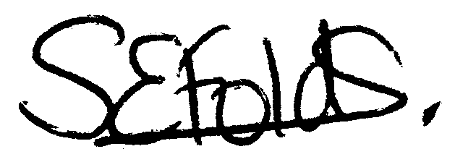

Samantha Folds
Clerk to Mullion Parish Council

