MULLION PARISH COUNCIL AGENDA

I hereby summon you to attend the Mullion Parish Council Meeting to be held at 7.00pm on Tuesday 15 August 2023 in the Mullion Methodist Chapel Centenary Room, Churchtown, Mullion. The public and press are cordially invited to attend. Any plans are available to view from 6.30pm.

- Public Session
- Apologies for Absence
- To agree the Minutes of the Parish Council Meeting held on Tuesday 18 July 2023
- Declarations of Interest – Members to declare pecuniary and non pecuniary interests (including details thereof) in respect of any item(s) on this Agenda
- Report from Wildanet – Amanda Pennington
- Planning - See Attached list
7. Report from Cornwall Councillor Anthony Soady
8. Chairman and Clerks Comments
9. Public Rights of Way
10. Public Open Spaces
11. Highways
12. To receive any LGA 1972 Section 137 Requests for funding
13. To agree payment of invoices - Finance and Accounts
14. Other correspondence received

Exclusion of the Press and Public
Pursuant to the provision of the Public Bodies (Admissions to meetings) Act 1960, the press and public be excluded from the Meeting for the following items of business by reason of the confidential nature of the business to be transacted.

15. Planning Enforcement Matters

Meeting to withdraw if necessary under the Public Bodies Admissions to Meetings Act 1960 Section 1, Local Government Act 1972 Section 100 Sections 2 & 3 and Local Government Act 172 Schedule 12 Section 42. Given under my hand this Eighth Day of August 2023.

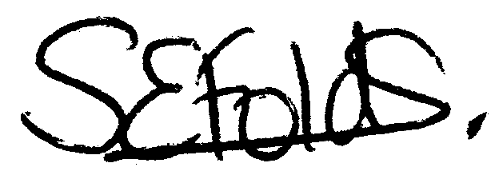

Samantha Folds
Clerk to Mullion Parish Council
Planning

Applications for discussion

PA23/03516 - Mr A Long - Polurrian Hotel, Polurrian Road - Construction of hotel extension to provide 15 new suites, extended function room space and integral spa facilities

PA23/05696 - Mrs Jean Stephens - Mill Wheel Caravan Park, Mullion Cove - Replacement of existing dwelling without compliance with condition 2 of decision notice PA16/11462 dated 07.03.2017, allowed on appeal APP/D0840/W/17/3183484 dated 13.03.2018

PA23/04747 – Natural England – Land East of A3083, Bochym - Construction of single storey office building, areas of hard standing and landscaped grounds

PA23/05197 – Mr R Fraser – Mulberry Cottage, Laflouder Lane – Works to tree under TPO, pruning back

PA23/05830 – Mr I Hamilton – Moonraker, 9 Commons Close – Works to trees under TPO, pruning back

Decisions made by Cornwall Council

Appeals

