MULLION PARISH COUNCIL AGENDA

I hereby summon you to attend the Mullion Parish Council Meeting to be held at 7.00pm on Tuesday 27 September 2022 in the Mullion Methodist Chapel Centenary Room, Churchtown, Mullion. The public and press are cordially invited to attend. Any plans are available to view from 6.30pm.

- Public Session
- Apologies for Absence
- To agree the Minutes of the Parish Council Meeting held on Tuesday 16 August 2022
- Declarations of Interest – Members to declare pecuniary and non pecuniary interests (including details thereof) in respect of any item(s) on this Agenda
- Planning
See Attached list
6. Report from Cornwall Councillor Anthony Soady
7. Chairman and Clerks Comments
8. Public Rights of Way
9. Public Open Spaces
10. Highways
11. To discuss the quotes received for the public toilet refurbishment
12. To receive the completed External Audit for 2021/22
13. To receive any LGA 1972 Section 137 Requests for funding
14. To agree payment of invoices - Finance and Accounts
15. Other correspondence received

Exclusion of the Press and Public
Pursuant to the provision of the Public Bodies (Admissions to meetings) Act 1960, the press and public be excluded from the Meeting for the following items of business by reason of the confidential nature of the business to be transacted.

16. Planning Enforcement Matters

Meeting to withdraw if necessary under the Public Bodies Admissions to Meetings Act 1960 Section 1, Local Government Act 1972 Section 100 Sections 2 & 3 and Local Government Act 172 Schedule 12 Section 42. Given under my hand this Twentieth day of September 2022.

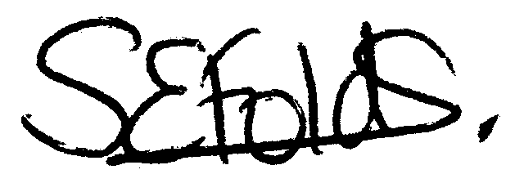

Samantha Folds
Clerk to Mullion Parish Council
Planning

Applications for discussion

PA22/079963 - Mr G Summersall - Carne Quarry, Meaver Road - Proposed rear extension to existing residential home

Decisions made by Cornwall Council

PA22/06177 - Mr & Mrs J Kincaid – Alban, Lender Lane - Proposed loft conversion, extensions, internal alterations and raised patio - Approved

PA22/04378 – Mr M Bannon - Land And Buildings Adj To Porthpradnack, Ghost Hill, Predannack - Construction of a detached dwelling within the domestic grounds of Porthpradnack – Refused

PA22/05240 - Mr S Sharland & Miss D Gilmore – Clifden, Polurrian Cliffs - Proposed demolition of existing dwelling and erection of 2 dwellings without compliance with condition 2 of appeal decision notice APP/D0840/W/21/3278787 dated 09/02/2022 - PA21/01125 – Withdrawn

PA22/05697 - Mullion Cove Hotel - Mullion Cove Hotel, Mullion Cove - Change of use from studio to serviced apartment with new raised decking area – Approved

PA22/06821 - Mr D Ashcroft - 31 Clifden Close - Extension and alterations to dwelling and detached studio – Withdrawn

PA22/06412 - Mr & Mrs Barnett – Manebe, 83 Laflouder Fields - Rear & Side extension to dormer bungalow at ground and first floor level - Approved

Appeals

