MULLION PARISH COUNCIL AGENDA

I hereby summon you to attend the Mullion Parish Council Meeting to be held
on Tuesday 15 December 2020 at 7.00pm remotely – online or by telephone via Microsoft Teams. The public and press are cordially invited to attend. Joining instructions are available by emailing the Clerk on mullionpc@btinternet.com or by calling 01326 241445.

- Public Session
- Apologies for Absence
3. To agree the Minutes of the Parish Council Meeting held on Tuesday 17 November 2020
4. Declarations of Interest – Members to declare pecuniary and non pecuniary interests (including details thereof) in respect of any item(s) on this Agenda
5. Planning
Applications
PA20/09916 - Mr A Punter - Mullion Gymnastics Centre, Trembel Lane - Demolition of existing portal frame structure, construction of two dwellings and retention of managers accommodation for use as a residential dwelling
PA20/09493 – Mr and Mrs Waterworth - Erection of conservatory - Rose Cottage, Predannack

Decisions
PA20/07820 - Mrs S Cavanagh - 2 Park En Venton - Proposed conservatory extension to the rear of an existing domestic dwelling – Approved
PA20/07980 - Mr J Butler - Briar 1 Pedn Y Ke Polurrian Road - New conservatory – Approved
PA20/08714 - Mr P Cook - 23 Clifden Close - Formation of side sun room extension – Approved
PA20/05677 - Mrs P Antwis – Tremellyon, Polurrian Road - Extension and alterations to existing property including creation of first floor accommodation, dormer window, rooflights and roof terrace – Approved
PA20/09957 - Mrs Powell - 73 Redannack North - Non-material amendment for the addition of side screens to extension french doors and flu for multi fuel burner - Approved

6. Report from Cornwall Councillor Mrs C Rule
7. Chairman and Clerks Comments
8. Public Rights of Way
9. Public Open Spaces
10. Highways
11. To discuss the Community Award
12. To discuss the Precept Demand for 2021/22
13. To receive any LGA 1972 Section 137 Requests for funding
14. To discuss the annual subscription to the Campaign to Protect Rural England - £36
15. To receive the External Auditor Report and Certificate 2019/20
16. To agree payment of invoices - Finance and Accounts
17. Other correspondence received

The Council is invited to pass the following resolution “that pursuant to the Public Bodies (Admissions to Meetings) Act 1960, the press and public be excluded from the meeting for the following items of business by reason of the confidential nature of the business to be transacted”.

18. Planning Enforcement Cases

Given under my hand this Eighth day of December 2020.
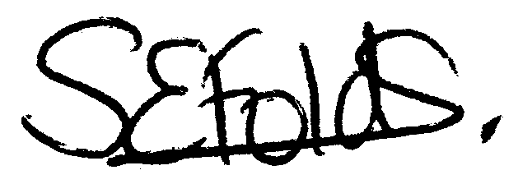

Samantha Folds
Clerk to Mullion Parish Council

