MULLION PARISH COUNCIL AGENDA

I hereby summon you to attend the Mullion Parish Council Meeting to be held
on Tuesday 17 April 2018 at 7.00pm
in the Mullion Methodist Chapel Centenary Room, Churchtown, Mullion.
Any plans are available to view from 6.30pm.

- Public Session – to include a presentation from Louise West, Lightening Fast Internet
- Apologies for Absence
3. To agree the Minutes of the Parish Council Meeting held on Tuesday 20 March 2018
4. Declarations of Interest – Members to declare registerable and non registerable interests (including details thereof) in respect of any item(s) on this Agenda
5. Planning Applications

Any Planning Applications received from the Planning Authority between the day of the publication of this Agenda and the day of the meeting.

Planning Decisions

PA18/01963 - Mr P Waterworth - Rose Cottage, Predannack - To erect a dual anthracite grey conservatory to the rear of the property - Approved

And any further Planning Decisions received from the Planning Authority between the day of the publication of this Agenda and the day of the meeting.

6. Report from Cornwall Councillor Mrs C Rule
7. Chairman and Clerks Comments
8. Public Rights of Way
9. Public Open Spaces
10. Highways
11. To affiliate to the Cornwall Association of Local Councils for 2018/19
12. To receive any LGA 1972 Section 137 Requests for funding
13. To agree payment of invoices - Finance and Accounts
14. Other correspondence received

Exclusion of the Press and Public
Pursuant to the provision of the Public Bodies (Admissions to meetings) Act 1960, the press and public be excluded from the Meeting for the following items of business by reason of the confidential nature of the business to be transacted.

15. To discuss the Tender for the Public Rights of Way Cutting Contract 2018-2021

Meeting to withdraw if necessary under the Public Bodies (Admissions to Meetings) Act 1960 Section 1, Local Government Act 1972 Section 100 Sections 2 & 3 and Local Government Act 172 Schedule 12 Section 42. Given under my hand this Tenth day of April 2018.
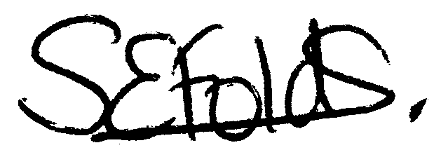

Samantha Folds
Clerk to Mullion Parish Council

