MULLION PARISH COUNCIL AGENDA

I hereby summon you to attend the Mullion Parish Council Meeting to be held
on Tuesday 15 June 2021 at 7.00pm in the Mullion Methodist Chapel School Room. The public and press are cordially invited to attend.

- Public Session
- Apologies for Absence
3. To agree the Minutes of the Annual Parish Meeting and the Parish Council Meeting held on Tuesday 18 May 2021
4. Declarations of Interest – Members to declare pecuniary and non pecuniary interests (including details thereof) in respect of any item(s) on this Agenda
5. Planning
Applications
PA21/02100 – Mr Long- Trevean, Mullion Cove – Amended plans
PA21/04917 - Mr & Mrs Upton - 9 Gibbons Fields - Proposed Extension
PA21/04451 – Mr D Lockey - 2 Police House, Lender Lane - Proposed single storey side extension with amended pedestrian access
Decisions
PA21/02854 - Mr & Mrs P Woodcock - 36 Tregellas Road - Proposed Extension and Internal Alterations – Approved
PA21/03513 - Mrs S Angove - The Cuddy, Polhorman Lane - Outline application for the proposed demolition of existing property and construction of two new two storey dwellings with garages and parking with access reserved – Withdrawn
PA21/02323 - John Dark - Land To The South-west Of Puffins, Meaver Road - Demolition of existing stable block and redundant brick building, and Construction of new, four bedroom, two storey dwelling with Agricultural Occupancy Condition - Approved
PA21/03361 - Mrs J Ireland - Hazeldene Nansmellyon Road Mullion TR12 7DQ Proposal: Formation of porch, conversion of loft with dormer and balcony, linked extension, and garage/workshop - Approved
PA21/03555 - Adrian Perry – Tresidder, Laflouder Lane - Variation of condition 2 and 6 in respect of PA16/00411 dated 04/04/16 (Demolition of existing house and construction of new replacement dwelling, including detailed landscaping proposals) - Approved
6. Report from Cornwall Councillor Mr Anthony Soady
7. Chairman and Clerks Comments
8. Public Rights of Way
9. Public Open Spaces
10. Co-option of new Councillor presentations
11. Village Hall Custodial Trustee Report
12. Tremenhee Car Park overnight parking
13. Adoption of the Code of Conduct 2021 version
14. Highways
15. To receive any LGA 1972 Section 137 Requests for funding
16. To agree payment of invoices - Finance and Accounts
17. Other correspondence received

The Council is invited to pass the following resolution “that pursuant to the Public Bodies (Admissions to Meetings) Act 1960, the press and public be excluded from the meeting for the following items of business by reason of the confidential nature of the business to be transacted”.

18. Planning Enforcement Cases
19. Co-option of new Councillor vote

Given under my hand this Eighth day of June 2021.
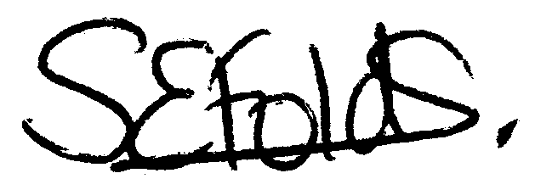

Samantha Folds - Clerk to Mullion Parish Council

