MULLION PARISH COUNCIL AGENDA

I hereby summon you to attend the Annual Mullion Parish Council Meeting to be held at 7.00pm on Tuesday 18 May 2021 in the Mullion Methodist Chapel Centenary Room, Churchtown, Mullion. The public and press are cordially invited to attend. Any plans are available to view from 6.30pm.

- Election of Chairman
- Election of Vice-Chairman
- Public Session
- Apologies for Absence
- To agree the Minutes of the Parish Council Meeting held on Tuesday 20 April 2021
- Declarations of Interest – Members to declare personal and prejudicial interests (including details thereof) in respect of any item(s) on this Agenda
- Planning Applications
PA21/03361 - Mrs J Ireland – Hazeldene, Nansmellyon Road Mullion - Formation of porch, conversion of loft with dormer and balcony, linked extension, and garage/workshop
PA21/02497 - Mr Punter - The Grange, Trembel Lane - Minor alteration and extension works
PA21/03513 - Mrs S Angove SF Developers - The Cuddy, Polhorman Lane - Outline application for the proposed demolition of existing property and construction of two new two storey dwellings with garages and parking with access reserved
PA21/03555 - Adrian Perry – Tresidder, Laflouder Lane - Variation of condition 2 and 6 in respect of PA16/00411 dated 04/04/16 (Demolition of existing house and construction of new replacement dwelling, including detailed landscaping proposals)
Any further Planning Applications received from the Planning Authority between the day of the publication of this Agenda and the day of the meeting.
Planning Decisions
PA21/01754 - Mr & Mrs P Ward - 31 Trembel Road - Proposed Extension and Internal Alterations - Approved
Any Planning Decisions received from the Planning Authority between the day of the publication of this Agenda and the day of the meeting.
8. Report from Cornwall Councillor Anthony Soady
9. Chairman and Clerks Comments
10. Public Rights of Way
11. Public Open Spaces
12. Highways
13. To discuss a dispensation for voting on matters relating to the Playing Field as Trustees
14. To receive the Annual Insurance Policy for 2021-2022
15. To approve the monthly payments to Mullion In Bloom
16. To receive any LGA 1972 Section 137 Requests for funding
17. Annual Accounts to Year End 31 March 2021
i) To complete the Annual Governance Statement for the Year Ending 31 March 2021
ii) To receive and approve the internally audited accounts for the Year Ending 31 March 2021
iii) To receive and note the report of the Internal Auditor
iv) To appoint an Internal Auditor for 2021-22
18. To agree payment of invoices - Finance and Accounts
19. Other correspondence received
Exclusion of the Press and Public
Pursuant to the provision of the Public Bodies (Admissions to meetings) Act 1960, the press and public be excluded from the Meeting for the following items of business by reason of the confidential nature of the business to be transacted.
20. Planning Enforcement Matters
21. To discuss the Clerk’s Salary Scale in accordance with the NJC
Meeting to withdraw if necessary under the Public Bodies Admissions to Meetings Act 1960 Section 1, Local Government Act 1972 Section 100 Sections 2 & 3 and Local Government Act 172 Schedule 12 Section 42. Given under my hand this Eleventh day of May 2021.

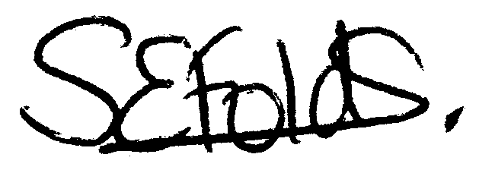
Samantha Folds - Clerk to Mullion Parish Council

