MULLION PARISH COUNCIL AGENDA

I hereby summon you to attend the Mullion Parish Council Meeting to be held
on Tuesday 17 July 2018 at 7.00pm
in the Mullion Methodist Chapel Centenary Room, Churchtown, Mullion.
Any plans are available to view from 6.30pm.

- Public Session
- Apologies for Absence
3. To agree the Minutes of the Parish Council Meeting held on Tuesday 19 June 2018
4. Declarations of Interest – Members to declare registerable and non registerable interests (including details thereof) in respect of any item(s) on this Agenda
5. Planning Applications
PA18/05305 - Mr P Waterworth - Rose Cottage, Predannack - Application for an existing Lawful Development Certificate in respect of a static caravan within the curtilage of Rose Cottage, used all year round as a self contained annexe by the applicant's friends and family
PA18/05801- Mr & Mrs K Penney - Little Pendower, Nansmellyon Road - Proposed extension and internal alterations
PA18/05570- Mr And Mrs C Rendall - 24 Tregellas Road - Application for change of use domestic workshop to hairdressing salon
PA18/06318 – Mr T Ramsey – Morlanow, Lender Lane – Tree Works
Any Planning Applications received from the Planning Authority between the day of the publication of this Agenda and the day of the meeting.

Planning Decisions

And any further Planning Decisions received from the Planning Authority between the day of the publication of this Agenda and the day of the meeting.

6. Report from Cornwall Councillor Mrs C Rule
7. Chairman and Clerks Comments
8. Public Rights of Way
9. Public Open Spaces (inc. Spending of Amenity Money)
10. Highways
11. To Co-opt a Councillor onto the Parish Council
12. To receive any LGA 1972 Section 137 Requests for funding
13. To agree payment of invoices - Finance and Accounts
14. Other correspondence received

Meeting to withdraw if necessary under the Public Bodies (Admissions to Meetings) Act 1960 Section 1, Local Government Act 1972 Section 100 Sections 2 & 3 and Local Government Act 172 Schedule 12 Section 42. Given under my hand this Tenth day of July 2018.

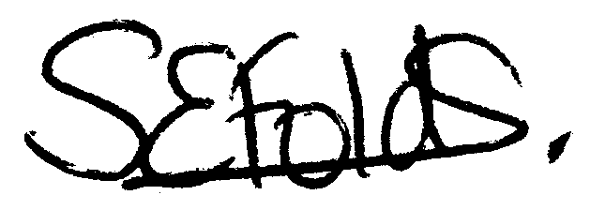

Samantha Folds
Clerk to Mullion Parish Council

