MULLION PARISH COUNCIL AGENDA

I hereby summon you to attend the Mullion Parish Council Meeting to be held
on Tuesday 16 February 2021 at 7.00pm remotely – online or by telephone via Microsoft Teams. The public and press are cordially invited to attend. Joining instructions are available by emailing the Clerk on mullionpc@btinternet.com or by calling 01326 241445.

- Public Session
- Apologies for Absence
3. To agree the Minutes of the Parish Council Meeting held on Tuesday 19 January 2021
4. Declarations of Interest – Members to declare pecuniary and non pecuniary interests (including details thereof) in respect of any item(s) on this Agenda
5. Planning
Applications
PA20/10999 – Mr P Skerrett - Former Campden House, The Commons - Application for reserved matters (appearance, landscaping, layout and scale) for the proposed construction of a new two bedroom, single storey dwelling following outline permission PA18/05838 and temporary siting of a mobile home during construction
PA21/00277 - Mr A Macaulay - Predannack Manor, Predannack - Conversion of redundant agricultural buildings to 7 residential units with garages and parking space, in respect of variation of condition 2 – change of garage roof from pitched to a flat, green roof

Decisions
PA20/10608 - Mr S Sandow – Treryn, 22 Meres Valley - First floor extension – Approved
PA20/09493 - Mr & Mrs Waterworth - Rose Cottage, Predannack - Erection of conservatory – Approved
PA20/11282 - Mrs C. Ta'Torin - 50 Tregellas Road - Proposed Extension and Internal Alterations - Approved

6. Report from Cornwall Councillor Mrs C Rule
7. Chairman and Clerks Comments
8. Public Rights of Way – including the LMP Offer for 2021-22
9. Public Open Spaces
10. To discuss the extension of the Cemetery
11. Highways
12. To receive any LGA 1972 Section 137 Requests for funding
13. To agree payment of invoices - Finance and Accounts
14. Other correspondence received

The Council is invited to pass the following resolution “that pursuant to the Public Bodies (Admissions to Meetings) Act 1960, the press and public be excluded from the meeting for the following items of business by reason of the confidential nature of the business to be transacted”.

15. Planning Enforcement Cases

Given under my hand this Ninth day of February 2021.
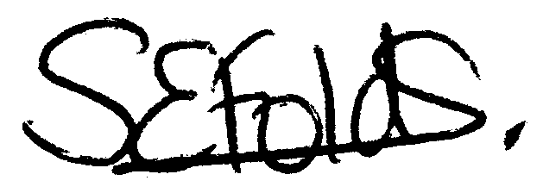

Samantha Folds
Clerk to Mullion Parish Council

