MULLION PARISH COUNCIL AGENDA

I hereby summon you to attend the Mullion Parish Council Meeting to be held at 7.00pm on Tuesday 18 April 2023 in the Mullion Methodist Chapel Centenary Room, Churchtown, Mullion. The public and press are cordially invited to attend. Any plans are available to view from 6.30pm.

- Public Session
- Apologies for Absence
- To agree the Minutes of the Parish Council Meeting held on Tuesday 21 March 2023
- Declarations of Interest – Members to declare pecuniary and non pecuniary interests (including details thereof) in respect of any item(s) on this Agenda
- Planning - See Attached list
6. Report from Cornwall Councillor Anthony Soady
7. Chairman and Clerks Comments
8. Public Rights of Way
9. Public Open Spaces
10. Highways
11. To receive any LGA 1972 Section 137 Requests for funding
12. To agree payment of invoices - Finance and Accounts
13. Other correspondence received

Exclusion of the Press and Public
Pursuant to the provision of the Public Bodies (Admissions to meetings) Act 1960, the press and public be excluded from the Meeting for the following items of business by reason of the confidential nature of the business to be transacted.

14. Planning Enforcement Matters

Meeting to withdraw if necessary under the Public Bodies Admissions to Meetings Act 1960 Section 1, Local Government Act 1972 Section 100 Sections 2 & 3 and Local Government Act 172 Schedule 12 Section 42. Given under my hand this Eleventh Day of April 2023.

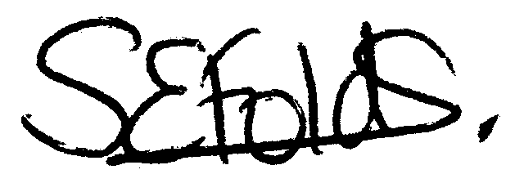

Samantha Folds
Clerk to Mullion Parish Council
Planning

Applications for discussion

PA23/01855 – Polurrian Hotel – Demolition of defective retaining structure and bin store. Construction of new garage and bin store

Decisions made by Cornwall Council

PA23/01154 - 8 Laflouder Fields - Proposed extension and alterations – Approved

PA23/01152 - St Meriadoc, 57 Laflouder Fields - Proposed Loft Conversion, Extensions and Internal Alterations - Approved

Appeals

