MULLION PARISH COUNCIL AGENDA

I hereby summon you to attend the Mullion Parish Council Meeting to be held
on Tuesday 20 November 2018 at 7.00pm
in the Mullion Methodist Chapel Centenary Room, Churchtown, Mullion.
Any plans are available to view from 6.30pm.

- Public Session
- Apologies for Absence
3. To agree the Minutes of the Parish Council Meeting held on Tuesday 16 October 2018
4. Declarations of Interest – Members to declare pecuniary and non pecuniary interests (including details thereof) in respect of any item(s) on this Agenda
5. Planning Applications
PA18/09470 – Mr & Mrs Cullen – Chy an Gres, Lender Lane – Extend property by two bedrooms above exiting garage and utility room
Any Planning Applications received from the Planning Authority between the day of the publication of this Agenda and the day of the meeting.
Planning Decisions
PA18/07828 - Mrs C Matthews – Hobthrush, 1 Churchy Fields, Laflouder Fields - Annex extension with terrace area, new dormer windows and kitchen window. Creation of new parking area – Approved
PA18/08783 - Mr G Atkinson & Mrs S Flynn - 36 Trembel Road - Proposed extension, internal alterations and parking bay – Approved
PA18/07442 - Mr M Tonkin - Land Rear Of Parc Luar, Nansmellyon Road - New Dwelling and Associated Works - Approved
PA18/06490 - Mr & Mrs P Waterworth - Rose Cottage, Predannack - Retention of side windows and formation of single storey side extension to form bedroom and lounge. Retrospective for retention of garage/storage shed - Approved
PA18/08230 - Mr T Hassell -Mullion Cove Hotel - Proposed spa building, landscaping and upgrading of existing outdoor pool with variation of condition 2 of decision PA18/03662 dated 11/07/2018 to allow minor material amendments to the design of the proposed Spa building - Approved

And any further Planning Decisions received from the Planning Authority between the day of the publication of this Agenda and the day of the meeting.
6. Report from Cornwall Councillor Mrs C Rule
7. Chairman and Clerks Comments
8. Public Rights of Way
9. Public Open Spaces (inc. Cemetery provision and CCTV and car park signage)
10. Highways
11. To receive any LGA 1972 Section 137 Requests for funding
12. To agree payment of invoices - Finance and Accounts
13. Other correspondence received

Meeting to withdraw if necessary under the Public Bodies (Admissions to Meetings) Act 1960 Section 1, Local Government Act 1972 Section 100 Sections 2 & 3 and Local Government Act 172 Schedule 12 Section 42. Given under my hand this Thirteenth day of November 2018.
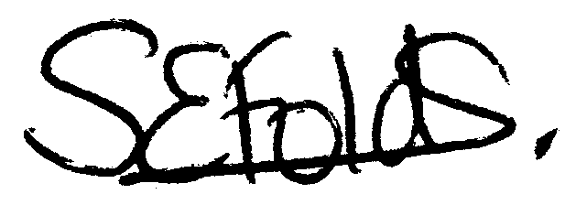

Samantha Folds
Clerk to Mullion Parish Council

