MULLION PARISH COUNCIL AGENDA

I hereby summon you to attend the Mullion Parish Council Meeting to be held
on Tuesday 26 October 2021 at 7.00pm in the Mullion Methodist Chapel Centenary Room. The public and press are cordially invited to attend.

- Public Session

2. Apologies for Absence

3. To agree the Minutes of the Parish Council Meeting held on Tuesday 21 September 2021 and the Extraordinary Meeting held on Tuesday 28 September 2021

4. Declarations of Interest – Members to declare pecuniary and non pecuniary interests (including details thereof) in respect of any item(s) on this Agenda

5 Report from Cat Lee – National Trust Representative

6. Planning

See Attached list

7. Report from Cornwall Councillor Mr Anthony Soady

8. Chairman and Clerks Comments

9. Public Rights of Way

10. Public Open Spaces

11. Highways

12. To discuss the draft Lone Working Policy

13. To receive any LGA 1972 Section 137 Requests for funding

14. To agree payment of invoices - Finance and Accounts

15. Other correspondence received

The Council is invited to pass the following resolution “that pursuant to the Public Bodies (Admissions to Meetings) Act 1960, the press and public be excluded from the meeting for the following items of business by reason of the confidential nature of the business to be transacted”.

16. Planning Enforcement Cases

Given under my hand this Nineteenth day of October 2021.
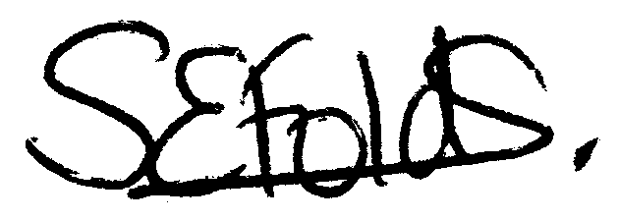

Samantha Folds - Clerk to Mullion Parish Council
Planning

Applications for discussion

PA21/07481 – Hospital Cross, Helston - Creation of retail park

PA21/09693 – Mr I Stanley – Parc Venton House, Garro Lane – Application for works to trees covered by a Tree Preservation Order

PA21/08671 – Clahar Cottage, Trewoon Road – Listed Building Consent: Internal alterations to ground and first floor elements, removal of existing section of external block work wall from north west elevation to be replaced with cob blocks, lime render and the fitment of a new window within the former window opening

PA21/09715 – Mr B McCorkill – Pastel Dyr, 81 Laflouder Fields – Proposed extension and alterations

PA21/09344 - Mr & Mrs D Brush - 69 Redannack North - Proposed ground and first floor extension and associated works

PA21/09003 – Mr R Fraser - Mulberry Cottage, Laflouder Lane - Application for work to a tree with a TPO - fell Monterey pine

PA21/09957 – Mr J Owens – Ros Gwydn, Trewoon Road – Proposed dwelling

Decisions made by Cornwall Council

PA21/00277 - Mr Alasdair Macaulay - Predannack Manor - Conversion of redundant agricultural buildings to 7 residential units with garages and parking space with variation of condition 2 of decision notice PA16/05044 dated 05.04.2017 - Approved

PA20/05008 - Charles Hunt - Land North of Park En Venton - Construction of 10 Affordable and 5 Open Market Homes with associated drainage and road works – Withdrawn

PA21/07133 - Mr & Mrs P Tams - 7 Tregellas Road - Proposal: Proposed extension to form Garage - Approved

PA21/07910 - Ms S Peters - Honeysuckle Chy, The Commons - Extension and alterations to existing bungalow, including the addition of a new first floor – Approved

PA21/08072 - Mr O Schoning - 14 Clifden Close - Ground floor extension to rear of property with balcony above. Alterations to roof at rear of property to create new pitched roof over master bedroom. New doors to ground floor extension and new doors to bedroom and hallway leading on to balcony - Approved

Appeals

PA21/01125 - Clifden, Polurrian Cliffs – Proposed demolition of existing dwelling and erection of 2 dwellings – appeal lodged

PA21/01794 - Gwel Teg, 47 Laflouder Fields - Change of use from office to ancillary accommodation and occasional holiday let – appeal lodged

