MULLION PARISH COUNCIL AGENDA

I hereby summon you to attend the Mullion Parish Council Meeting to be held at 7.00pm on Tuesday 17 January 2023 in the Mullion Methodist Chapel Centenary Room, Churchtown, Mullion. The public and press are cordially invited to attend. Any plans are available to view from 6.30pm.

- Public Session
- Apologies for Absence
- To agree the Minutes of the Parish Council Meeting held on Tuesday 20 December 2022
- Declarations of Interest – Members to declare pecuniary and non pecuniary interests (including details thereof) in respect of any item(s) on this Agenda
- Planning
See Attached list
6. Report from Cornwall Councillor Anthony Soady
7. Chairman and Clerks Comments
8. Public Rights of Way
9. Public Open Spaces
10. Highways
11. To receive any LGA 1972 Section 137 Requests for funding
12. To agree payment of invoices - Finance and Accounts
13. Other correspondence received

Exclusion of the Press and Public
Pursuant to the provision of the Public Bodies (Admissions to meetings) Act 1960, the press and public be excluded from the Meeting for the following items of business by reason of the confidential nature of the business to be transacted.

14. Planning Enforcement Matters

Meeting to withdraw if necessary under the Public Bodies Admissions to Meetings Act 1960 Section 1, Local Government Act 1972 Section 100 Sections 2 & 3 and Local Government Act 172 Schedule 12 Section 42. Given under my hand this tenth day of January 2023.

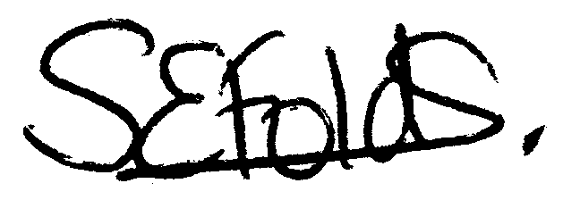

Samantha Folds
Clerk to Mullion Parish Council
Planning

Applications for discussion

PA22/11203 - Mr & Mrs J Widdicombe – Moorlands, Nansmellyon Road - Replacement of two-storey extension with a new extension, additional access to Nansmellyon Road from the site

Decisions made by Cornwall Council

PA22/10277 - Mr Richard Gilbert - Former Half Tides, Laflouder Lane - Proposal Non-material amendment in relation to decision notice PA16/04222 dated 20/09/2016 for moving the location of the building 1m to the south-west and lower some of the floor levels by up to 500mm whilst maintaining the approved roof ridge heights - Not acceptable as amendment

PA22/09622 - Mr & Mrs Pickett - 4 Trembel Road, Mullion - Single-storey flat roof side extension - Approved

Appeals

