MULLION PARISH COUNCIL AGENDA

I hereby summon you to attend the Mullion Parish Council Meeting to be held
on Tuesday 17 November 2020 at 7.00pm remotely –online or by telephone via Microsoft Teams. The public and press are cordially invited to attend. Joining instructions are available by emailing the Clerk on mullionpc@btinternet.com or by calling 01326 241445.

- Public Session
- Apologies for Absence
3. To agree the Minutes of the Parish Council Meeting held on Tuesday 20 October 2020
4. Declarations of Interest – Members to declare pecuniary and non pecuniary interests (including details thereof) in respect of any item(s) on this Agenda
5. Planning
Applications
PA20/08645 - Mrs C Matthews - Land Rear of The Cuddy, Polhorman Lane - Outline application for a dwelling with all matters reserved except access
PA20/08714 – Mr P Cook – 23 Clifden Close – Formation of side sun room
PA20/05677 – Mr Antwis – Tremellyon, Polurrian Road – Extension and alterations to existing porperty including creation of first floor accommodation, dormer window, rooflights and roof terrace
Decisions
6. Report from Cornwall Councillor Mrs C Rule
7. Chairman and Clerks Comments
8. Public Rights of Way
9. Public Open Spaces
10. Highways
11. To discuss the Community Award
12. To receive any LGA 1972 Section 137 Requests for funding
13. To agree payment of invoices - Finance and Accounts
14. Other correspondence received

The Council is invited to pass the following resolution “that pursuant to the Public Bodies (Admissions to Meetings) Act 1960, the press and public be excluded from the meeting for the following items of business by reason of the confidential nature of the business to be transacted”.

15. Planning Enforcement Cases

Given under my hand this Tenth day of November 2020.
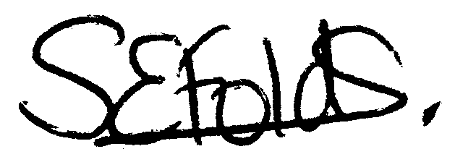

Samantha Folds
Clerk to Mullion Parish Council

