MULLION PARISH COUNCIL AGENDA

I hereby summon you to attend the Annual Mullion Parish Council Meeting to be held at 7.00pm on Tuesday 15 May 2018 in the Mullion Methodist Chapel Centenary Room, Churchtown, Mullion. The public and press are cordially invited to attend. Any plans are available to view from 6.30pm.

- Election of Chairman
- Election of Vice-Chairman
- Public Session
- Apologies for Absence
- To agree the Minutes of the Annual Parish Meeting and the Parish Council Meeting held on Tuesday 17 April 2018
- Declarations of Interest – Members to declare personal and prejudicial interests (including details thereof) in respect of any item(s) on this Agenda
- Planning Applications
Any Planning Applications received from the Planning Authority between the day of the publication of this Agenda and the day of the meeting.
Planning Decisions
PA17/06862 - Mr M Heath - Venton Arriance, Trewoon Road - Alterations and extension to existing building to form a dwelling - Approved
PA18/02018 - Co-Operative Food - Mullion Post Office, Nansmellyon Road - Application for consent to display advertisement signs - Approved
And any further Planning Decisions received from the Planning Authority between the day of the publication of this Agenda and the day of the meeting.
8. Report from Cornwall Councillor Mrs C Rule
9. Chairman and Clerks Comments
10. Public Rights of Way
11. Public Open Spaces
12. Highways
13. To review the Burial Fees for Mullion Cemetery and discuss the purchase of additional land
14. To discuss a dispensation for voting on matters relating to the Playing Field as Trustees
15. To receive the Annual Insurance Policy for 2018-2019
16. To approve the monthly payments to Mullion In Bloom
17. To receive the Annual RoSPA report in relation to St Mellans Park
18. To receive any LGA 1972 Section 137 Requests for funding
19. Annual Accounts to Year End 31 March 2018
i) To complete the Annual Governance Statement for the Year Ending 31 March 2018
ii) To receive and approve the internally audited accounts for the Year Ending 31 March 2018
iii) To receive and note the report of the Internal Auditor
iv) To appoint an Internal Auditor for 2018-19
20. To agree payment of invoices - Finance and Accounts
21. Other correspondence received

Exclusion of the Press and Public
Pursuant to the provision of the Public Bodies (Admissions to meetings) Act 1960, the press and public be excluded from the Meeting for the following items of business by reason of the confidential nature of the business to be transacted.

22. To discuss the Clerk’s Salary Scale in accordance with the NJC

Meeting to withdraw if necessary under the Public Bodies Admissions to Meetings Act 1960 Section 1, Local Government Act 1972 Section 100 Sections 2 & 3 and Local Government Act 172 Schedule 12 Section 42. Given under my hand this Tenth day of May 2018.

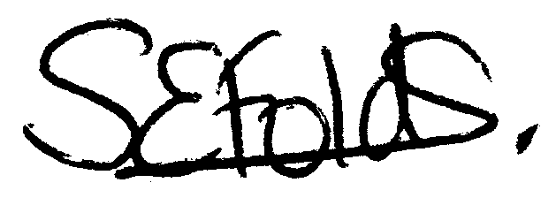

Samantha Folds - Clerk to Mullion Parish Council

