MULLION PARISH COUNCIL AGENDA

I hereby summon you to attend the Annual Mullion Parish Council Meeting to be held at 7.00pm on Tuesday 20 May 2025 in the Mullion Methodist Chapel Centenary Room, Churchtown, Mullion. The public and press are cordially invited to attend.

- Election of Chairman
- Election of Vice-Chairman
- Public Session
- Apologies for Absence
- To agree the Minutes of the Electors Meeting and Parish Council Meeting held on Tuesday 15 April 2025
- Declarations of Interest – Members to declare personal and prejudicial interests (including details thereof) in respect of any item(s) on this Agenda
- Planning
See Attached list
8. Report from Cornwall Councillor Rory Gow
9. Chairman and Clerks Comments
10. Public Rights of Way
11. Public Open Spaces inc. Mullion in Bloom payments
12. Highways
13. To discuss a dispensation for voting on matters relating to the Playing Field as Trustees
14. To receive the Annual Insurance Policy for 2025-2026
15. To affiliate to the Cornwall Association of Local Council for 2025/26
16. To appoint the Parish Council Representative for the Community Area Partnership
17. To receive any LGA 1972 Section 137 Requests for funding
18. Annual Accounts to Year End 31 March 2025
i) To complete the Annual Governance Statement for the Year Ending 31 March 2025
ii) To receive and approve the internally audited accounts for the Year Ending 31 March 2025
iii) To confirm that there are no conflicts with BDO LLP
iv) To appoint an Internal Auditor for 2025-26
19. To agree payment of invoices - Finance and Accounts
20. Other correspondence received

Exclusion of the Press and Public
Pursuant to the provision of the Public Bodies (Admissions to meetings) Act 1960, the press and public be excluded from the Meeting for the following items of business by reason of the confidential nature of the business to be transacted.

21. Planning Enforcement Matters
22. To discuss the Clerks Salary

Meeting to withdraw if necessary under the Public Bodies Admissions to Meetings Act 1960 Section 1, Local Government Act 1972 Section 100 Sections 2 & 3 and Local Government Act 172 Schedule 12 Section 42. Given under my hand this Thirteenth day of May 2025.

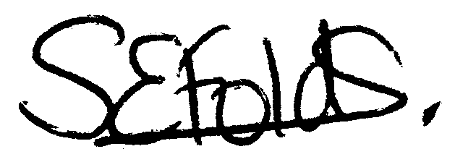

Samantha Folds - Clerk to Mullion Parish Council
Planning

Applications for discussion

PA25/02660 – Greenacres, Polurrian Road – Proposed extensions and alterations

PA25/03209 – Woodland Area, Woodlands – Application for tree works in a Tree Preservation Order Area

PA25/02649 – Flying Gulls Day Nursery, Mullion Primary School – Proposed play cabin for nursery

Decisions made by Cornwall Council

PA25/00209 - Hill House, Churchtown - Demolition of a glazed porch. Provision of a part single, part two storey extension. Re-roofing with additional solar panels, replacing glazing and upgrading of internal insulation to the existing building – Refused

PA25/02048 – White Wings, Polhorman Lane – Erection of conservatory - Approved

Appeals

PA23/09917 – Land east of Vounder Farmhouse, Meaver Road – Appeal Dismissed

